=========================================================
SQL PRACTICE NOTES
PRACTICAL-1 TOPIC: DDL, DML, DCL, TCL COMMANDS
DATABASE: BANK MANAGEMENT SYSTEM
=========================================================
=========================================================
SECTION 1 : DDL (DATA DEFINITION LANGUAGE)
=========================================================
DDL COMMANDS:
1. CREATE
2. ALTER
3. DROP
4. TRUNCATE
5. RENAME
=========================================================
QUESTION 1 - CREATE TABLE
=========================================================
SCENARIO:
The bank wants to create a table to store
customer transaction details.

QUERY:
CREATE TABLE bank_transactions (
txn_id INT PRIMARY KEY,
customer_name VARCHAR(50),
branch_name VARCHAR(50),
transaction_type VARCHAR(20),
amount DECIMAL(10,2),
transaction_date DATE
);

OUTPUT:
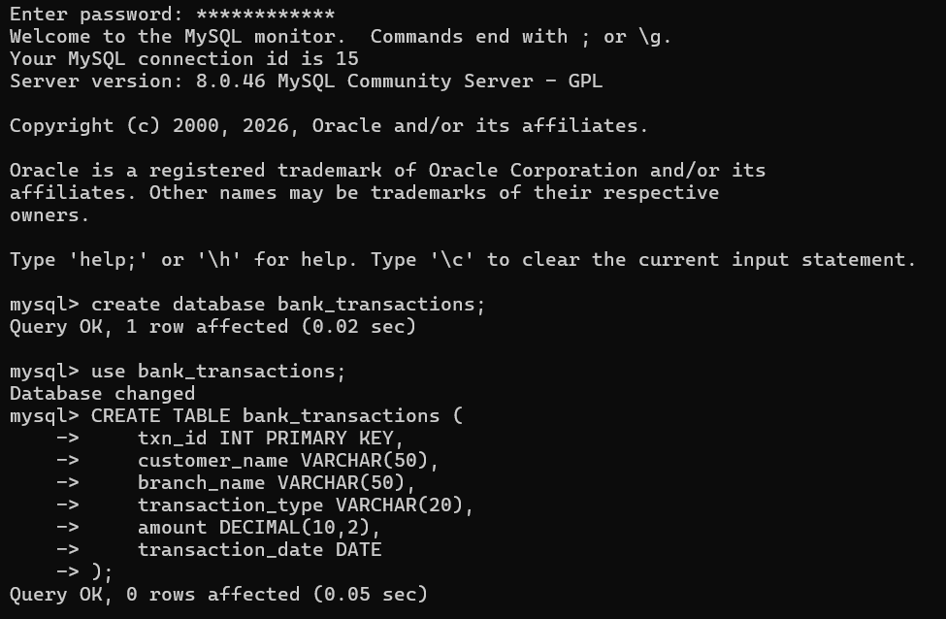

=========================================================
QUESTION 2 - ALTER TABLE ADD COLUMN
=========================================================
SCENARIO:
The bank wants to store account numbers
for every transaction.

QUERY:
ALTER TABLE bank_transactions
ADD account_no VARCHAR(20);

OUTPUT:
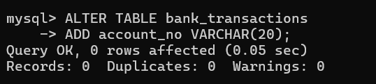

=========================================================
QUESTION 3 - ALTER TABLE MODIFY COLUMN
=========================================================
SCENARIO:
The bank wants to increase customer name length.

QUERY:
ALTER TABLE bank_transactions
MODIFY customer_name VARCHAR(100);

OUTPUT:
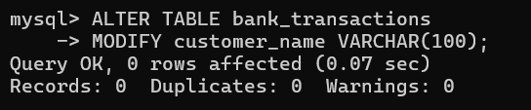

=========================================================
QUESTION 4 - RENAME TABLE
=========================================================
SCENARIO:
The bank wants to rename the transaction table.

QUERY:
RENAME TABLE bank_transactions
TO customer_transactions;

OUTPUT:
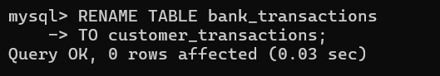

=========================================================
QUESTION 5 - TRUNCATE TABLE
=========================================================
SCENARIO:
The testing team wants to remove all records
without deleting the table structure.

QUERY:
TRUNCATE TABLE customer_transactions;

OUTPUT:

=========================================================
QUESTION 6 - DROP TABLE
=========================================================

SCENARIO:
The bank no longer requires an old backup table.

QUERY:

DROP TABLE bank_backup;

OUTPUT:

=========================================================
SECTION 2 : DML (DATA MANIPULATION LANGUAGE)
=========================================================

DML COMMANDS:
1. INSERT
2. UPDATE
3. DELETE
4. SELECT

=========================================================
STEP 1 : INSERT SAMPLE DATA
=========================================================

INSERT INTO customer_transactions VALUES
(101,'Ravi','Hyderabad','Deposit',5000,'2024-01-05',1),
(102,'Sita','Hyderabad','Withdrawal',2000,'2024-01-06' ,2),
(103,'Kiran','Vijayawada','Deposit',12000,'2024-01-08' ,3),
(104,'Anil','Vizag','Deposit',8000,'2024-01-10' ,4),
(105,'Priya','Hyderabad','Withdrawal',3500,'2024-01-11' ,5),
(106,'Ramesh','Vizag','Deposit',15000,'2024-01-12' ,6),
(107,'Keerthi','Vijayawada','Withdrawal',1000,'2024-01-13' ,7),
(108,'Rahul','Hyderabad','Deposit',9000,'2024-01-14' ,8),
(109,'Sneha','Vizag','Withdrawal',4000,'2024-01-15' ,9),
(110,'Madhu','Vijayawada','Deposit',11000,'2024-01-16' ,10);

OUTPUT:
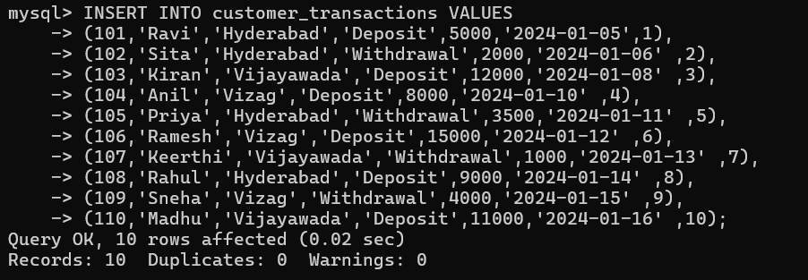

=========================================================
QUESTION 7 - INSERT
=========================================================

SCENARIO:
A new customer transaction must be recorded.

QUERY:

INSERT INTO customer_transactions
VALUES
(111,'Venu','Vizag','Deposit',7000,'2024-01-18');

OUTPUT:
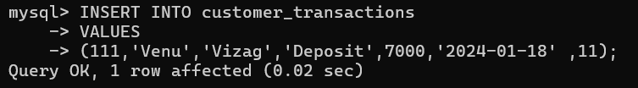

=========================================================
QUESTION 8 - UPDATE
=========================================================

SCENARIO:
Customer Priya's transaction amount was entered
incorrectly and must be corrected.

QUERY:

UPDATE customer_transactions
SET amount = 5000
WHERE txn_id = 105;

OUTPUT:
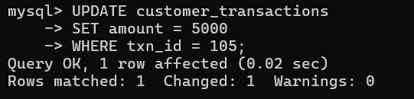

=========================================================
QUESTION 9 - DELETE
=========================================================

SCENARIO:
A duplicate transaction record must be removed.

QUERY:

DELETE FROM customer_transactions
WHERE txn_id = 111;

OUTPUT:
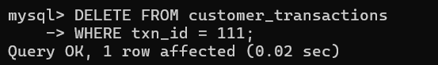

=========================================================
QUESTION 10 - SELECT
=========================================================

SCENARIO:
The branch manager wants to view all transactions.

QUERY:

SELECT *
FROM customer_transactions;

OUTPUT:
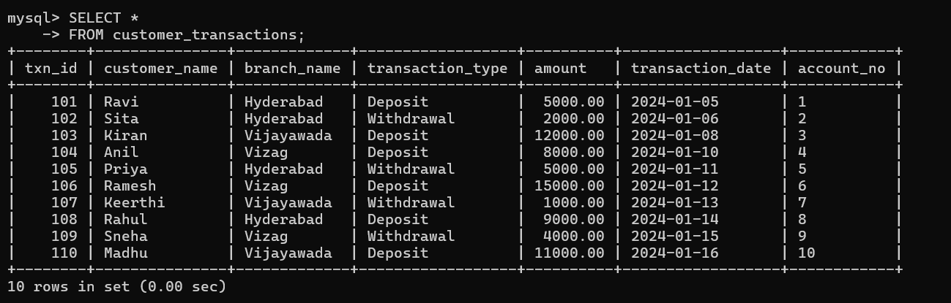

=========================================================
QUESTION 11 - SELECT WITH WHERE
=========================================================

SCENARIO:
The manager wants all deposits only.

QUERY:

SELECT *
FROM customer_transactions
WHERE transaction_type='Deposit';

OUTPUT:
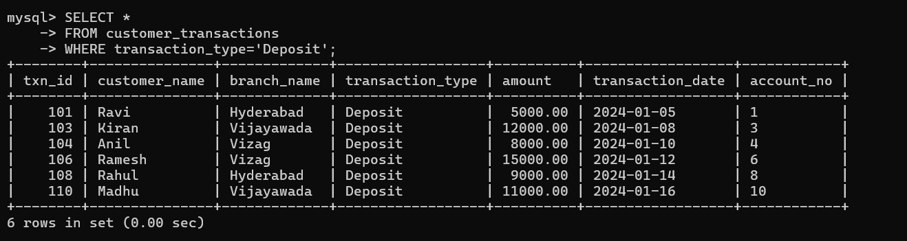

=========================================================
QUESTION 12 - SELECT WITH ORDER BY
=========================================================

SCENARIO:
Management wants transactions ranked by amount.

QUERY:

SELECT *
FROM customer_transactions
ORDER BY amount DESC;

OUTPUT:
